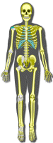  Skeletal | 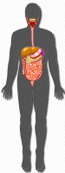  Digestive | 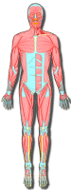  Muscular | 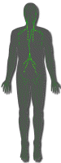  Lymphatic | 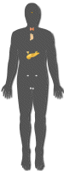  Endocrine
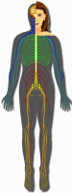  Nervous | 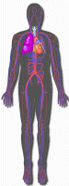  Cardiovascular | Male Reproductive | 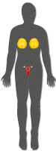  Female Reproductive | 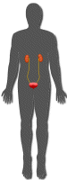  Urinary

http://www.biology4kids.com/ Click on Animal Systems and Begin!
http://www.turtlediary.com/grade-2-games/science-games/human-body.html Good and with games.
http://www.innerbody.com/ Great realistic images!

http://www.kidskonnect.com/subject-index/31-health/337-human-body.html
Kids Konnect. Approved, safe sites for students to use. Large List!
www.brainpop.com
to log in username Broomet password school Body system info is under the Health section

